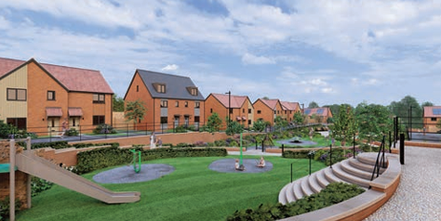


Annual Report
2025/2026
Resident-led housing management, community improvement and service performance

A YEAR OF PROGRESS
Stronger governance, improved tenant satisfaction, visible estate improvements and continued support for residents through regeneration.
New Park Village Tenant Management Co-operative Ltd
12 Valley Road, Wolverhampton, WV10 0NZ

Contents
1 Chairperson’s welcome
2 About New Park Village TMC
3 2025/26 at a glance
4 Governance and committee development
5 Staff and service delivery
6 Tenant Satisfaction Measures
7 Neighbourhood and estate improvements
8 Repairs and maintenance
9 Resident engagement, safety and wellbeing
10 Regeneration and New Homes
11 Social value and partnership working
12 Finance, audit and value for money
13 Priorities for 2026/27
14 Getting involved and contact details
15 Publication checks

Chairperson’s Welcome

Hello everyone and thank you for taking the time to read our Annual Report for 2025/26.
The past year has been one of significant change, progress and improvement for New Park Village TMC. Whilst there have been challenges, the organisation is now in a stronger position, with improved governance, clearer priorities and a renewed focus on delivering quality services for tenants and residents.
Over the year, we strengthened financial oversight, governance arrangements, policy review, resident engagement and service monitoring. The Committee has also established subgroups to support effective scrutiny and oversight across key areas of the business.
Our staffing structure has continued to evolve so that we have the right resources to support residents, improve services, strengthen community engagement and prepare for the significant changes that regeneration will bring.
Regeneration remains one of the most important developments affecting New Park Village. We have worked with residents, the Council, and development partners to keep tenants informed and supported, while ensuring that residents’ voices remain central to the redevelopment journey.
We recognise that there is still more work to do, particularly around communal areas, complaints handling, damp and mould, repairs follow-up and wider resident participation. We remain committed to continuous improvement and to providing the best possible service to our community.
On behalf of the Committee, thank you to our staff, partners, committee members and residents for your continued dedication, support and engagement.
Val McKean
Chairperson, New Park Village TMC

2. About New Park Village TMC
New Park Village TMC is a resident-led, not-for-profit organisation delivering housing management services on behalf of the local authority. It enables residents to play an active role in managing their homes and neighbourhood, helping services reflect local needs and priorities.
New Park Village was established in 1993 to provide quality, affordable social housing while building a strong community spirit. Residents formed the Tenant Management Co-operative to gain greater influence over housing management and local decision-making.

Area | What this means
Resident-led governance | Resident committee members set priorities, monitor performance, and strengthen accountability.
Local service delivery | Housing management, repairs coordination, estate services, resident engagement and support.
Partnership working | Strong relationships with the Council, Wolverhampton Homes, community safety partners, contractors and community organisations.
Homes and neighbourhood | A mix of houses, flats, maisonettes and bungalows within New Park Village.

3. 2025/26 at a Glance
Headline | 2025/26 achievement
70% overall satisfaction | Overall tenant satisfaction rose from 55% to 70%.
82% ASB satisfaction | Satisfaction with the approach to anti-social behaviour increased by 31 percentage points.
83% kept informed | Satisfaction with being kept informed increased by 27 percentage points.
Seven new bungalows | Seven energy-efficient two-bedroom bungalows were completed and relet.
Fencing programme started | Pro-Fence was appointed and phased estate fencing works commenced.
Improved access to information | A new website was developed to improve transparency and access to policies, services and updates.

4. Governance & Committee Development
The Committee provides resident-led governance by setting priorities, monitoring performance, ensuring compliance and holding the organisation to account. During 2025/26, work continued to clarify roles, strengthen governance and improve regular reporting to the Committee.

Committee Members
Role | Name
Chairperson | Val McKean
Vice Chairperson | Esther Gogo Hassan
Treasurer | Jennifer Hollyoak
Vice Treasurer | Danielle Pratt
Company Secretary | Sarah Stone
Vice Company Secretary | Steven Spencer
Committee Member | Mark Johnson
Committee Member | Margo Monaghan
Committee Member | Michelle Turner
Committee Member | Donna Marie Booth

Quarterly Reporting & Oversight
Enhanced quarterly reporting now gives the Committee regular oversight of performance, finance, repairs, tenant satisfaction, complaints, anti-social behaviour, regulatory compliance, redevelopment and community engagement. This supports informed decision-making and clearer monitoring of improvement plans and strategic priorities.

Committee Training & Development

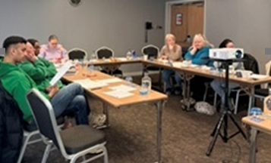
Committee members completed governance training delivered by Springboard Enterprise, supporting their understanding of roles, responsibilities, scrutiny, decision-making and accountability. Learning during the year also covered governance, regulatory compliance, Tenant Satisfaction Measures, performance monitoring, complaints and health and safety.
DEVELOPMENT IN 2026/27
Planned learning includes finance and budget monitoring, risk management, consumer standards, Awaab’s Law, safeguarding, complaints, equality and diversity, tenant engagement, regeneration awareness, cyber security and data protection.

5. Staff & Service Delivery
The staffing structure provides clear accountability for strategic leadership, housing management, repairs, estate services, and community development. As a small local team, clear responsibilities, good communication and partnership working are essential.
Role | Main responsibilities
Chief Officer – Nicola Dilks | Strategic leadership, governance, performance, regulatory compliance, business planning, finance oversight, staffing and partnerships.
Housing Services Manager – Kamran Aziz | Tenancy management, rent collection, ASB, complaints, allocations, resident involvement, operational delivery and regeneration support.
Repairs, Maintenance and Community Development Officer – Rachel Gavin | Repairs coordination, contractor liaison, estate services, environmental improvements, resident engagement, social value and community development.
Handyperson – Andrew Guest | Emergency, urgent and routine minor repairs, maintenance works and practical estate improvements.
Caretaker – Ayodeji Momodu | Communal area inspections, estate cleanliness, fly-tipping monitoring, grounds maintenance support and reporting environmental or safety concerns.

Workforce Achievements
- Embedded a revised staffing structure to strengthen local service delivery.
- Invested in staff training and development, including health and safety and operational learning.
- Improved coordination across housing management, repairs, estate services and community engagement.

6. Tenant Satisfaction Measures
The 2025/26 Tenant Satisfaction Measures show a positive direction of travel. Overall satisfaction increased from 55% in 2024/25 to 70% in 2025/26. The strongest improvements were in ASB handling, listening and acting on tenant views, keeping tenants informed, ease of contact and home safety.
Measure | 2024/25 | 2025/26 | Change
Overall satisfaction | 55% | 70% | +15
Well maintained home | 60% | 74% | +14
Safe home | 61% | 79% | +18
Repairs in last 12 months | 61% | 72% | +11
Time taken for repairs | 69% | 76% | +7
Communal areas | 71% | 56% | -15
Neighbourhood contribution | 58% | 67% | +9
Approach to ASB | 51% | 82% | +31
Listens and acts | 49% | 78% | +29
Kept informed | 56% | 83% | +27
Fairly and with respect | 66% | 82% | +16
Easy to deal with | 62% | 83% | +21
Complaints handling | 44% | 56% | +12

IMPROVEMENT FOCUS
Communal areas, complaints handling, damp and mould, repairs follow-up and increasing resident participation remain priorities. A Tenant Satisfaction Measure Improvement Action Plan supports the next stage of work.

7. Neighbourhood & Estate Improvements

Cannock Road Estate Improvement Project
A multi-agency estate improvement project brought together residents, New Park Village TMC, City of Wolverhampton Council, Wolverhampton Homes, Fire Safety teams, Police and ASB services. The estate tour identified environmental, health and safety and estate management concerns, leading to a coordinated action plan.
- Repairs to roofs and guttering and improvements to communal areas.
- Grounds maintenance, vegetation clearance, and fire safety signage.
- Enhanced monitoring of fly-tipping hotspots and additional caretaker inspections.
- Clearer action planning and regular estate checks to help maintain improvements.

Estate Tours & Next Steps
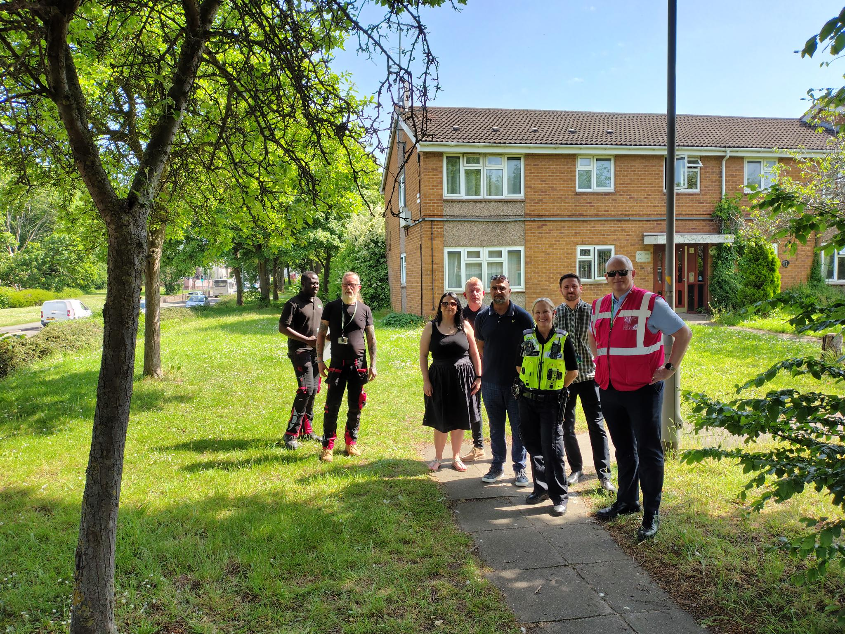
The Cannock Road approach continued estate tours across Malpas, Audlem and Orslow Walks. Actions, responsible officers, and targets are being recorded and monitored, with progress reported through resident updates and quarterly performance reporting. New Park Village will be working in conjunction with our partners across the whole of New Park Village and we welcome you to join us. We will be sending correspondence out to all residents when we are in your street in order for you to provide us feedback on improvements you feel are important to you and that of the estate.

Grounds Maintenance & Fly-tipping
Regular inspections and partnership working have strengthened the response to overgrown vegetation, litter, communal area concerns, and fly-tipping. New Park Village received targeted monitoring, additional caretaker visits and environmental improvement works. The organisation will continue to monitor recurring issues and work with relevant services to support a cleaner, safer estate. We are seeing a reduction in Fly-tipping reports however, this is an area where we have put robust measures in place and are still working with Wolverhampton Homes and the City of Wolverhampton Council to continue to reduce fly-tipping on the estate.

Fencing Improvement Programme
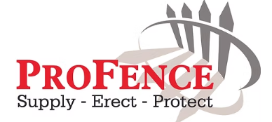
Pro-Fence was appointed to deliver a major estate fencing improvement programme. A phased delivery route has now been established, enabling works to be planned and communicated effectively across the estate. To support resident engagement, a fencing information event was held for tenants whose properties are included within the programme. The event provided residents with the opportunity to meet representatives, discuss the proposed works, ask questions and raise any concerns. The event was well attended and received positively, helping to build understanding and support for the project. Works continue to be coordinated in phases, supported by ongoing resident communication and local engagement, to improve security, estate appearance and neighbourhood standards while minimising disruption.

8. Repairs & Maintenance
Repairs satisfaction increased from 61% to 72%, while satisfaction with the time taken to complete repairs increased from 69% to 76%. In-house delivery through the Handyperson has supported emergency, urgent and routine repairs and contributed to better responsiveness and budget savings.
- Continue to improve follow-up communication after repairs.
- Develop more robust analysis of in-house repairs, savings and value for money.
- Maintain focus on damp and mould, building safety and communal areas.
- Use performance reporting to monitor delivery and identify recurring issues.

9. Resident Engagement, Safety and Wellbeing

Communication & Involvement
Resident engagement included surveys, consultations, leaflets, website updates, newsletters, estate activities and plans for a Community Activities Working Group. Residents are encouraged to share feedback, attend activities, join working groups, and help shape future priorities.

New website
A new New Park Village TMC website is being developed to improve access to service information, policies, performance information, contact details and estate updates. The website supports clearer communication, improved transparency, and easier access to tenant resources. Residents will be updated once the new website has gone live.

Severn Trent Water

Severn Trent Water has continued to support New Park Village through partnership working, resident engagement activities, and by promoting access to financial assistance and affordability schemes. Their involvement has helped residents access advice on reducing water costs, managing household finances, and using water more efficiently, while also supporting wider community initiatives and social value objectives. We value the positive relationship we have developed with Severn Trent Water and look forward to continuing our work together to benefit residents and strengthen our community.

Community Safety
Police and ASB drop-in sessions have provided residents with direct access to advice, reporting routes and support. The sessions strengthen information sharing and help partner agencies coordinate responses to local concerns.

Head 4 Health
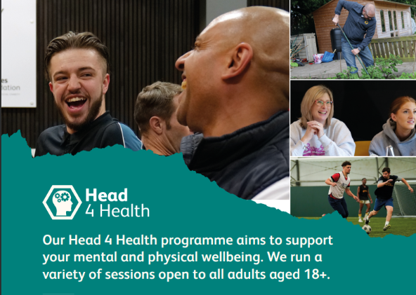
Regular partnership meetings with the Wolves Foundation’s Head 4 Health programme have supported plans for accessible physical health, mental wellbeing and healthier lifestyle activities, with an emphasis on reducing social isolation and responding to resident needs.

Community Events

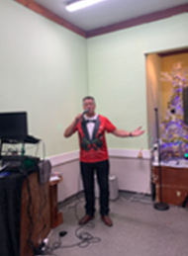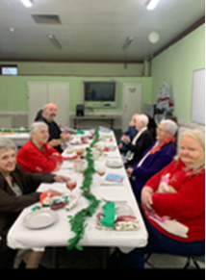
The Christmas dinner brought residents together for a seasonal event. Meals were also delivered to residents who could not attend, helping ensure that the activity was inclusive and reached people in their own homes. Residents of New Park Village over 55’s enjoyed a three-course meal and had a sing-along with Dougie Swain who hit the 60’s 70’s, 80’s and 90’s music and we also had a ‘Sing-along’ with carols and mince pies.

New Park Village held a Christmas Party for children on the estate. This was a success and the children enjoyed seeing Santa, playing games, having a buffet and seeing the Naughty Elf!

10. Regeneration & New Homes
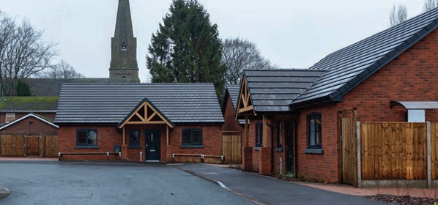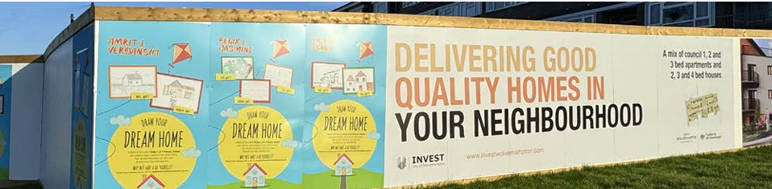
Regeneration remains one of the most significant programmes affecting New Park Village. The scheme aims to improve housing quality, energy efficiency, and the wider estate environment while supporting residents through decant, rehousing and allocation processes.
- Phase One demolition of 101 properties was completed by DSM in May 2025.
- Seven two-bedroom energy-efficient bungalows were completed by Keon Homes in January 2026 and relet by New Park Village TMC.
- A redevelopment action plan was formalised to identify affected tenants, update household information, and assess housing and support needs.
- Weekly redevelopment drop-in support was introduced at the New Park Village office, giving residents access to information about rehousing, applications, medical assessments and future housing options.
- Local staff remain involved in shortlisting, property offers, allocations and exit inspections so that local knowledge informs the process.
OUR COMMITMENT
Residents will remain informed and supported throughout the regeneration programme, with clear records, consistent advice, and tailored support for affected households.

11. Social Value & Partnership Working
New Park Village TMC has continued to develop opportunities that improve resident wellbeing and strengthen the local community. Partnership working is intended to ensure that regeneration delivers wider and longer-term benefits beyond housing improvements.
Partner or programme | Contribution and opportunity
Keon Homes and The Way Youth Zone | Developing opportunities to connect young residents with positive activities, support and wider social value benefits.
Severn Trent Water | Promoting advice, affordability support and assistance for residents experiencing financial pressure with household water costs.
Wolves Foundation – Head 4 Health | Supporting physical and mental wellbeing, healthier lifestyles and reduced social isolation.
West Midlands Police and ASB Team | Resident drop-ins, reporting routes, advice, and coordinated responses to community safety concerns.
Council, Wolverhampton Homes and other agencies | Estate improvements, regeneration support, safeguarding, environmental action and resident services.

Further opportunities identified include employability support, youth engagement, healthy eating, first aid, community safety, training, education, and support for older residents. Resident surveys and community discussions will help determine which activities are taken forward.

12. Finance, Audit & Value for Money
The financial audit was carried out by Jerroms during the week commencing 18 May 2026. At the point of the June Board Report, detailed audit feedback had not yet been received, although the requested documentation had been provided, and the accounts were reported as up to date.

Finance area | Position for the report
Audit | Jerroms audit was undertaken during the week commencing 18 May 2026.
Budget | The June Board Report described the budget position as stable.
Value for money | Further repairs cost analysis is being developed to evidence savings and improve reporting.
Final accounts | Available on request and overview will be provided at AGM

13. Priorities for 2026/27
- Deliver a high-performing housing service, including rent collection, repairs and tenancy management.
- Provide a reliable responsive repairs service and strengthen repairs follow-up.
- Improve building safety, damp and mould management and communal area standards.
- Increase resident involvement in decision-making, scrutiny and community activity.
- Improve communication through newsletters, website updates and “You Said, We Did” reporting
- Strengthen governance, compliance, financial controls, risk management and KPI reporting.
- Support residents through cost-of-living pressures and effective signposting.
- Support tenants affected by redevelopment through clear communication and accessible local advice.
- Continue estate tours across Cannock Road, Malpas, Audlem and Orslow and monitor agreed actions.
- Develop social value opportunities with partners around health, youth, employability, training and community cohesion.

14. Getting Involved & Contact Details
New Park Village TMC is a resident-led organisation and welcomes tenant involvement. Residents can become shareholders, attend events, share feedback, take part in surveys, join working groups and consider becoming Committee members.
Contact method | Details
Office | New Park Village TMC, 12 Valley Road, New Park Village, Wolverhampton, WV10 0NZ
Telephone | 01902 552670
Email | newparkvillage2@wolverhampton.gov.uk
Website | www.npv.org.uk

